**Progress Report I**

**On**

**ParkMeRight**

**Submitted By**

**Monika Sharma**

**Tarun Dhiraj**

**Under the guidance of**

**Prof. DiptiTheng**

**Department of CSE**

**Department of Computer Science & Engineering**



**Department of Computer Science & Engineering**

**G. H. Raisoni College of Engineering**

**Digdoh Hills, Nagpur**

**Session 2013-2014**

**INDEX**

* DATABASE
* WEB APP
  + Login Page
  + Form for First Time Users
  + Terms and Conditions
* PHASE TO BE COMPLETED IN PHASE II

**Database:**

The database that would be connected to the Web as well as Android app is created. The back end used is MySql. Following figure explains the structure of the database created.

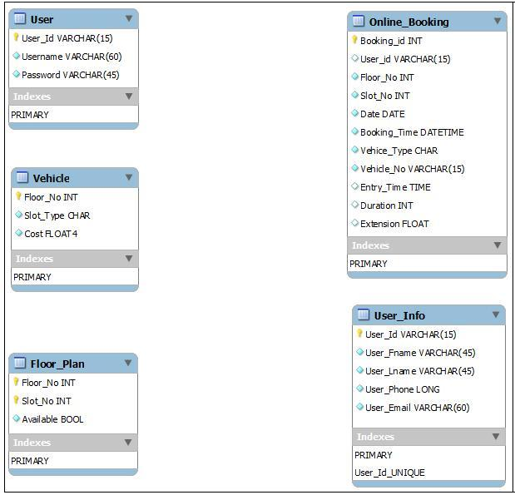

Figure 1: Database Structure

The database consists of five tables named User, Vehicle, Floor_Plan, Online_Booking, User_Info.

* The User table would consist of the information required by the user to access the facilities of both the apps.
* Vehicle table contains the fields to store the records related to the vehicle that would be parked in multistorey building.
* The Floor_Plan table is for all the information related to the different floors of the building such as the floor number, number of slots and if any space is left on that floor or not.
* The table named Online_Booking stores the relevant records of all the users who have parked their vehicles in that building on that particular day.
* The User_Info table is used for storing the information of all the users using the apps, either web app or the Android one.

**Web App:**

The Web app is made to be used by the person in charge of that car park so that the updates can be made regularly without fail regarding free space availability, advance booking, entry and exit of cars etc. The person involved will look after the correct and precise allotment of space without any inconvenience to the users.

First of all the user would have to Login to the system using the username or ID provided and the password. The figure 2 shows how the Login page of Web app looks like.

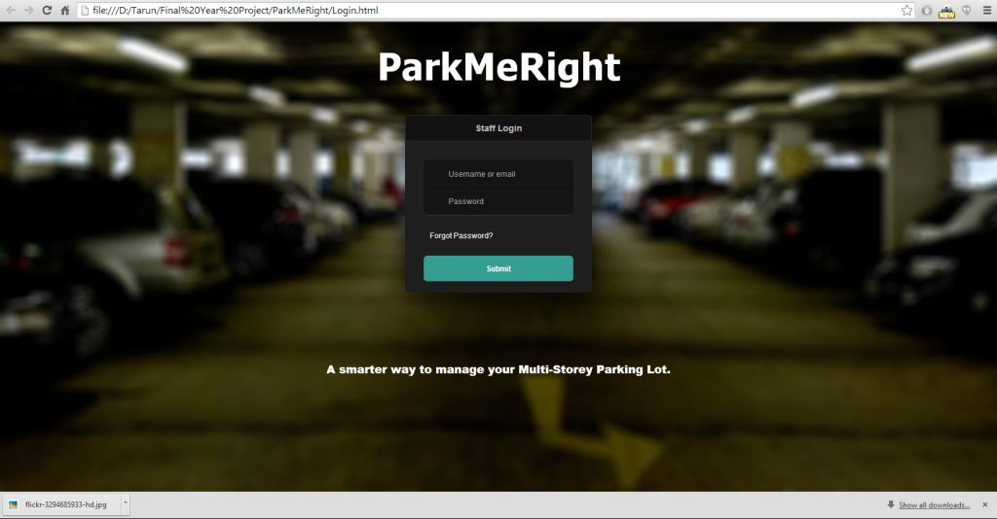

Figure 2: Login Page of Web app

The person using Web App for the first time would have to fill some mandatory information in order to proceed further as shown in figure 3. Without filling this form, they would not be allowed to access their account. Except for the first time, the user would directly get the access to their account and they can carry on with their work.

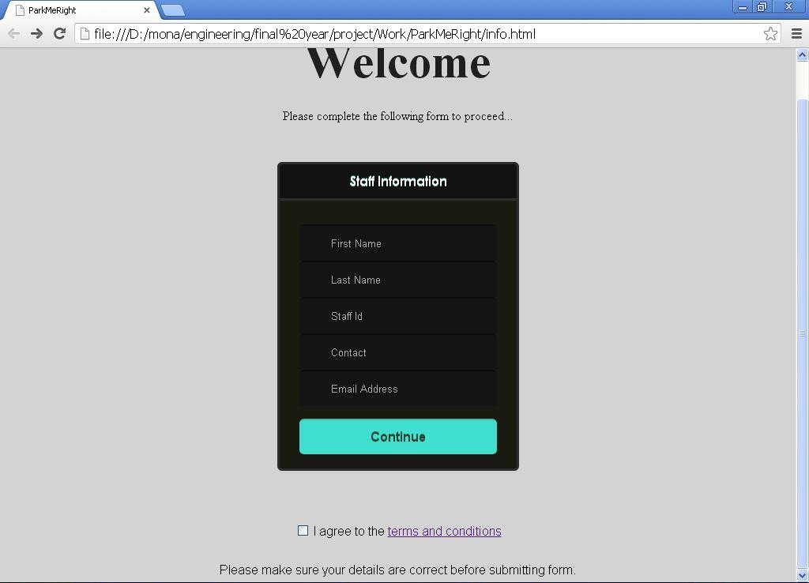

Figure 3: Form to be filled out by first time Users

The user would have to agree to the terms and conditions of the organization before proceeding to their account and avail the facilities. Without their agreement they cannot continue with their work. Figure 4 is the page that opens when clicked on the “terms & conditions” link on the above page.

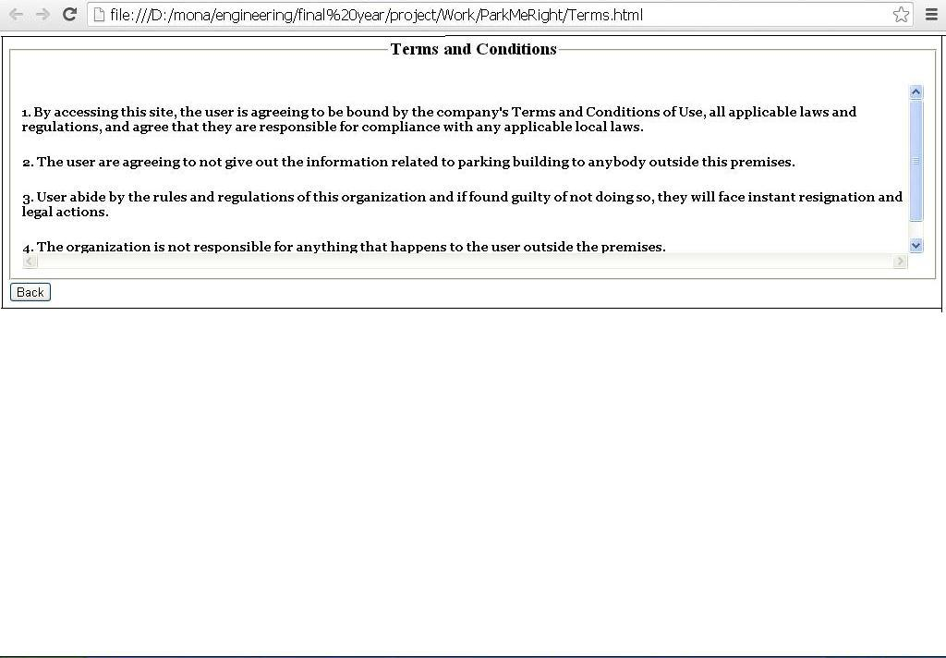

Figure 4: Terms and Conditions

**Work To Be Completed in Phase II:**

The project team would work to achieve the following milestones in next phase:

1. All the UI Pages of Web app as well as Android app would be created.
2. The Web pages would get linked to the MySql database.